**Computer Project**

**Name:** **Amr Ahmed Fawzi Mostafa**

**B.N:552**

**Date: 6/6/2021**

**Topic: Artificial Intelligence**

**Application Brief:**

[**Artificial intelligence**](https://en.wikipedia.org/wiki/Artificial_intelligence)**, defined as intelligence exhibited by machines, has many applications in today's society. More specifically, it is**[**Weak AI**](https://en.wikipedia.org/wiki/Weak_AI)**, the form of AI where programs are developed to perform specific tasks, that is being utilized for a wide range of activities including**[**medical diagnosis**](https://en.wikipedia.org/wiki/Medical_diagnosis)**,**[**electronic trading platforms**](https://en.wikipedia.org/wiki/Electronic_trading_platform)**,**[**robot control**](https://en.wikipedia.org/wiki/Robot_control)**, and**[**remote sensing**](https://en.wikipedia.org/wiki/Remote_sensing)**. AI has been used to develop and advance numerous fields and industries, including finance, healthcare, education, transportation, and more.**

**Source Code:**

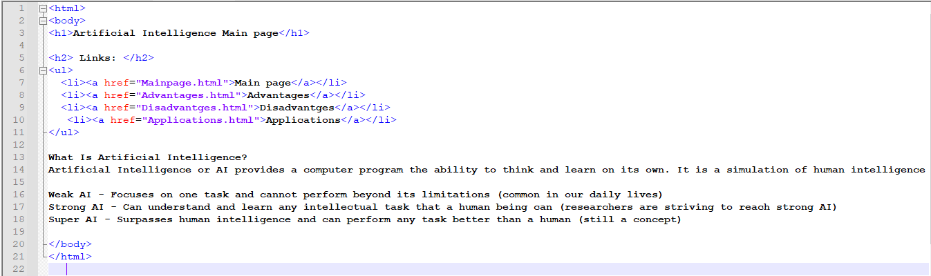

**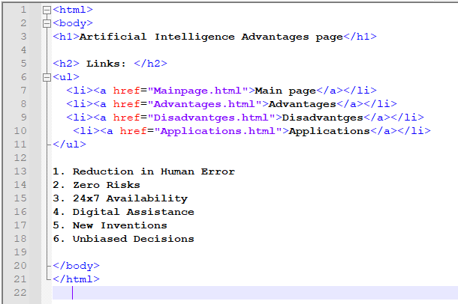 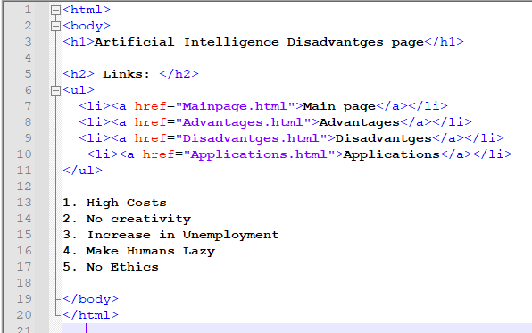  
 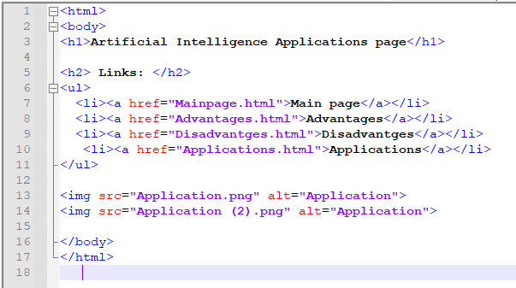**

**Screen Shots:**



